Elliot Putnam

CS-255 System Analysis and Design

Module Three Assignment – Evaluate a Process Model

11/11/23

**Prompt**: Hamp Crafts is a family-owned craft store that has been in business for decades. Its current operations are limited to its physical (brick-and-mortar) storefront. Recently, the owners have determined that one of the best ways to gain additional revenue is through online sales. The online sales process is new to the owners. They need to fully understand how online ordering works, and how it can be integrated with their current in-store purchase and supply process.

You are a systems analyst working with Hamp Crafts to modernize their business. First, you will analyze their current purchase and supply process for items in their brick-and-mortar store. Then you will suggest ways to integrate new processes for an online storefront.

The current process model (shown below) starts off with the customer. The customer creates an order and submits it to the online store. The next step is “receive customer order” which most likely entails customer details like name, shipping address, and any other important order information. Next is “check out”, where the customer most likely inputs payment data and submits the final order. Now, the system branches into two separate processes, “fulfill order” and “carrier”. Carrier is for which transportation servicer will be used. This could include shipping sizes, weight of order, and volume of order to ensure the correct carrier is selected, it’s then passed into the “shipper” process where that branch ends. For “fulfill order” data is also sent to the “shipper” process, along with a delivery plan that is sent to the “choose supplier” process. Once a supplier is chosen, it forwards contract negotiations to the “supplier” which then moves it to “shipper” which now receives data from three sources.

Sources of data during this process start with the customer. Customers provide shipping, payment, and personal data. The online store itself provides data to the customer in the form of inventory, and any other types of marketplace adjustments like sales, out of order, or shipping times. The supplier and carriers are also providing data to storefront in the form of schedules and inventories. This data is required for the company to fulfill the customers order, as well as provide them with a tracking number, and estimated delivery time. Lastly, all this data is pooled together and transferred to the shipper which is responsible for providing shipping and tracking data through the tree back to the root, that is the customer.

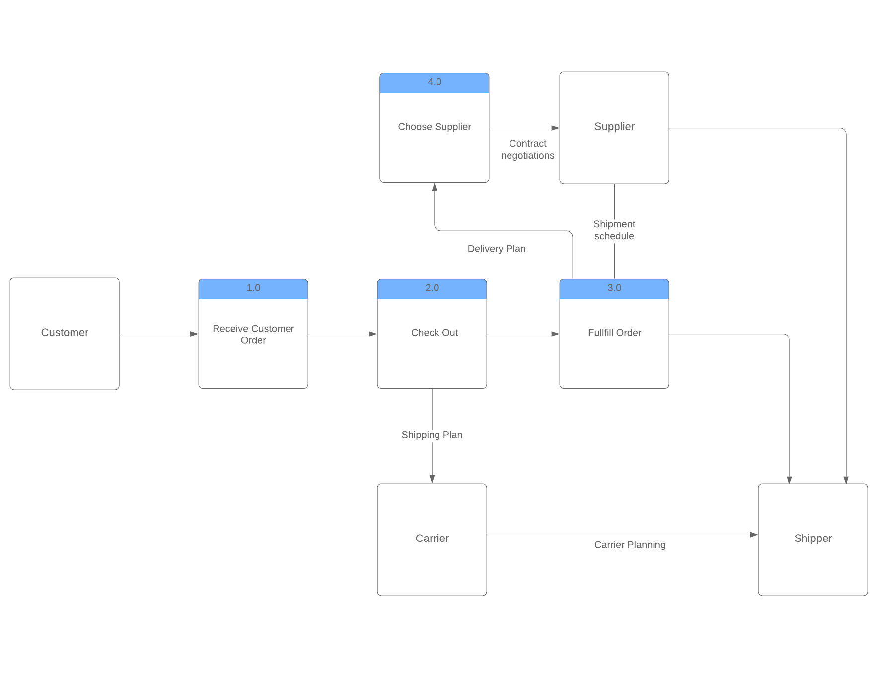

An additional process that can been included in this process model would be to have automatic confirmations, “send confirmation” to any recipient that may need one. This includes the customer, the storefront, and all service providers the storefront uses. This ensures that orders are accounted for, and each process has accountability attached to it. Hamp Crafts should integrate their data into a cloud-based storage system to ensure data does not get lost and the processes get completed in a regular and timely manner. Transitioning to cloud-based data centers allows for increased redundancy, faster speeds, and ability to scale customer demand seamlessly. Adding a process that handles order fulfillment automatically will also make the process more manageable. From this process, the customer can receive their confirmation, or if the order does not meet fulfillment criteria, a notification that an item is not available. Being automated will keep the system moving and you will not have to rely on employees to manually check inventories of multiple vendors.

I would recommend to the customer (Hamp Crafts) that their process model can be kept and modified to fit the new standard. I don’t believe it would be cost effective to create an entirely new model as the only elements that need to be added are ones that are reflective of what has been done, which are all already part of the process. Between each step (1-4) an automated notification / delivery system can be placed. After the customer process, another step can be added which sends their order through the data center.